HOSS SR16Rotational Switch
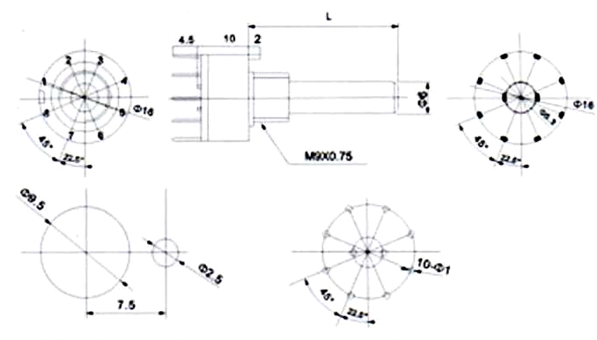
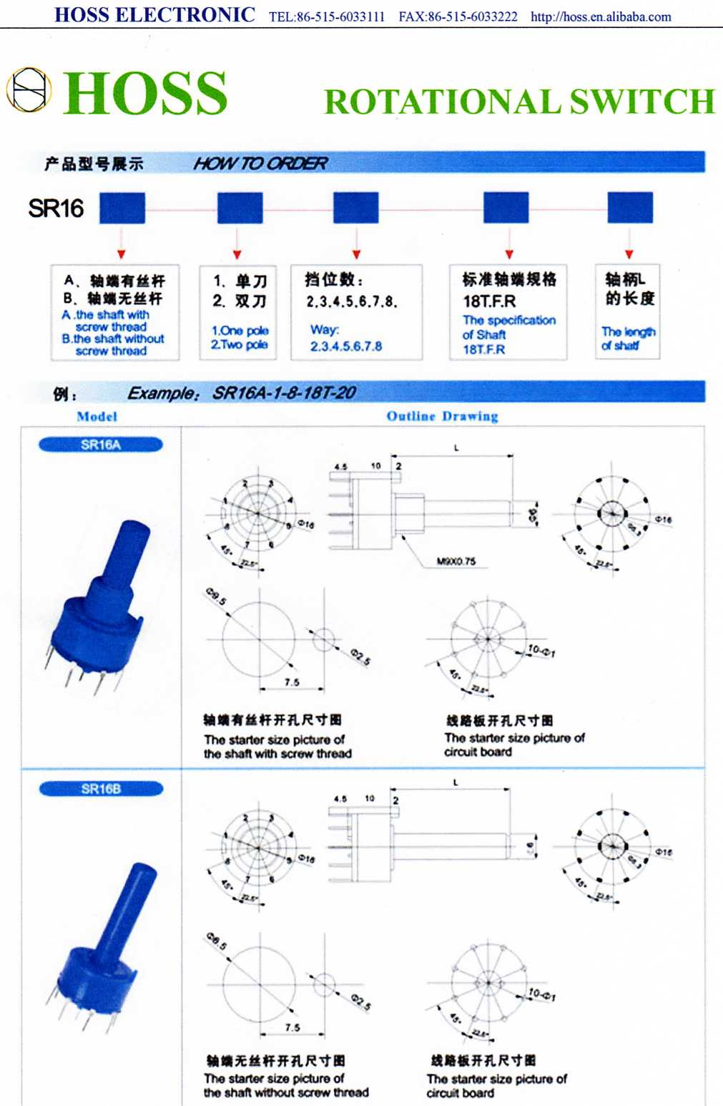

SR26A

The starter size picture
of circuit board
The starter size picture of
the shaft without screw thread

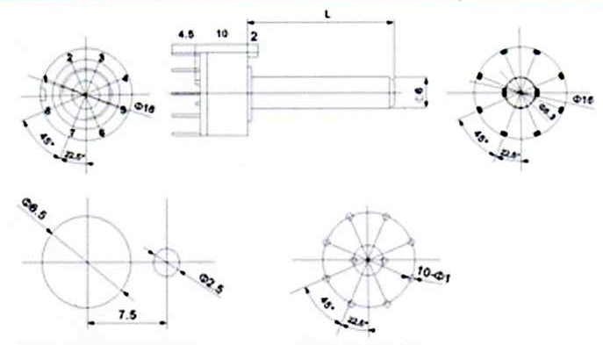

SR16B

The starter size picture of
circuit board
The starter size picture of
the shaft without screw thread

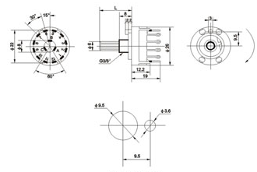

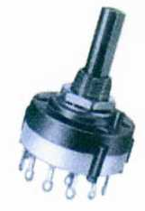

SR26

The fitting size of shaft terminal

HOW TO ORDER e.g.: SR16A-18T-2-3-18T-20

SR16 | A | Shaft  terminal type | 2 | 3 | 20
Series | Screw thread type | 18T | Pole number | steps | Shaft length
SR16  SR26 | A=the shaft with  screw thread  B=the shaft without  screw thread | 18T, F,D,R | 1=One pole  2=Two pole | 2,3,4,5,6,7,8

PACKAGING

MODEL | PCS/UNITS
SR16 | 5 PER PACKET,100 PER BOX
SR26 | 3 PER PACKET,100 PER BOX

http://www.chinahoss.com
http://hoss.en.alibaba.com

